Wellbeing For Life Board
Our Wellbeing For Life Plan
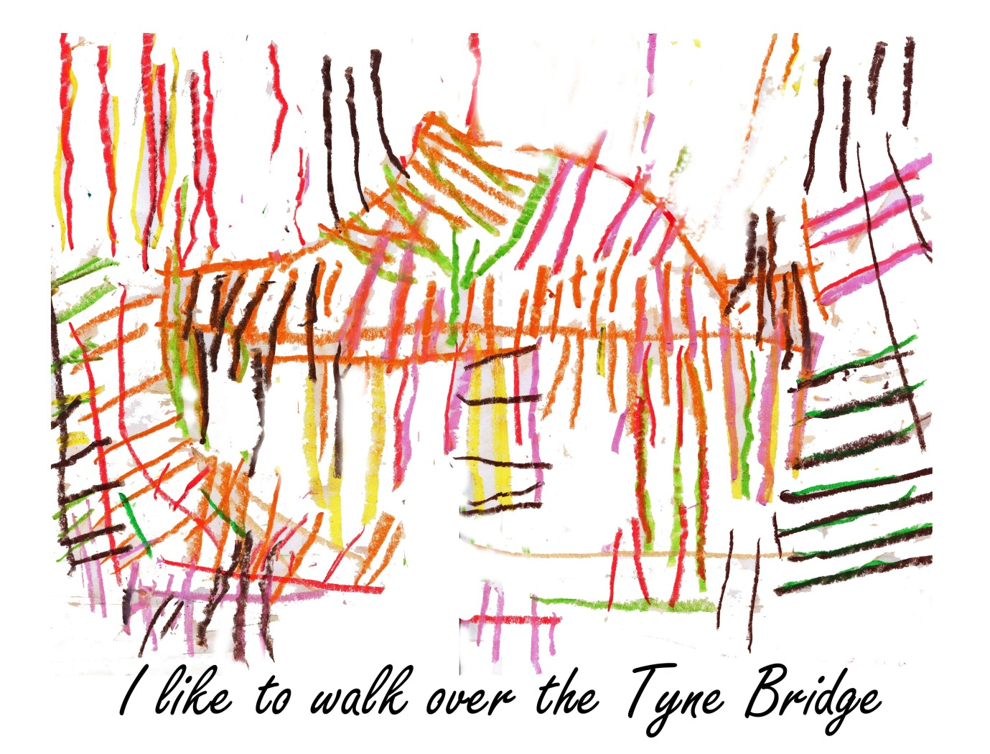
Easier to Read
What do people think version April 2013

Cover picture by Sharon / The Hub at Arcadea
Welcome and what this plan is all about
Hello
This is the Wellbeing for Life Board's plan to help Newcastle people have good health and wellbeing - to be healthier and happier.
Who is the Wellbeing For Life Board?
- Newcastle City Council
- NHS Newcastle West Clinical Commissioning Group
- NHS Newcastle North and East Clinical Commissioning Group
They have to prepare this plan jointly - a ‘Health and Wellbeing Strategy and to do this they are working in partnership with
- Newcastle upon Tyne Hospitals NHS Foundation Trust
- Northumberland, Tyne and Wear NHS Foundation Trust
- Northumbria University
- Newcastle University
- The voluntary and community sector in Newcastle

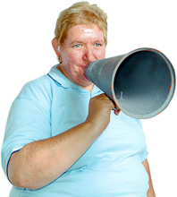 If you live, work or learn in Newcastle the Board wants to hear what you think.
We would especially like to know
- What you think are the things we need to do first this year
- What you think of the ideas for working together in the plan
You can comment at www.letstalknewcastle.co.uk

Or send your views by 31 May 2013 to wellbeing@newcastle.gov.uk
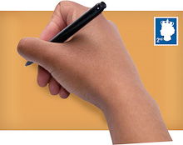
Or post to:
Wellbeing for Life team
Room 103, Newcastle Civic Centre, Newcastle upon Tyne NE1 8XS

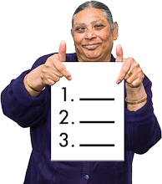What this plan is all about
Some people don’t get as many chances of having good health and feeling good about life. There are many reasons for this .The Wellbeing for Life Board wants to lead the city and our organisations to work with local people to tackle these so everyone in the city who lives or works here has the same chances having good health, feeling good about life and being happy.
The main things this plan says are
- The plan is not just about health and social care services. It’s about all the main things that affect people’s lives like having a job , a good place to live , having a good start in life , keeping independent , getting out and about and having the right support when its needed.

- We have a lot of good things to build on as a city - like people , buildings , businesses and connections with other places.

- Despite tough times the people of Newcastle have ideas, strengths, energy and spirit that organisations haven’t made the most of yet.

- To do more with all the good things we have we need to get people thinking differently. This will mean recognising and building on people’s skills, strengths, ideas , dreams and connections. Doing this lets local people take action to improve their own, and others’ health and how they feel about themselves . Its by the people for the people ways of solving problems and making things happen . People will not just receive services. They will think of what is needed and be a part of or lead what we do.

- To do this they must feel valued and supported all the way by services and organisations. Local people have to be truly equal partners.

- For many services in Newcastle this may mean rethinking how they work and how they serve the people of Newcastle.

- This plan isn’t just about big ideas. When it’s finished we want organisations to say in writing how they will help the big ideas happen

Part One
The things that affect people's health or wellbeing
This part of the plan looks at the things that affect people’s health or wellbeing.
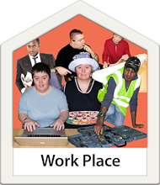Jobs
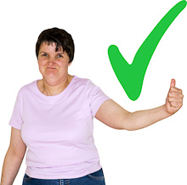What we have now
Newcastle has lots of strengths and successes in getting people jobs – we already have a plan called Newcastle a Working City “ that we are using to bring successful business to Newcastle.

What we want to see happen
- We want to offer people fair employment - having a wage they can live on, having a good place to work with jobs they enjoy and can feel proud of doing
- But we know that when times are tough there won’t be many new jobs around
- We need to make sure young people get the best chances they can – learning skills and making the most of talents that employers will want.
- We need to think about people are employed and if we can do things differently to get people back into work
- We need to think about people getting older and how this affects what jobs are available and how they are offered
- We want to encourage people to buy local goods
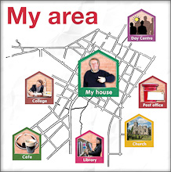Good place to live - buildings, streets and places to go
A good place to live here means people
- live in homes that meet their needs, people can get out and about easily with good active travel routes and accessible transport links to the facilities that people want or need to use,
- they can use the internet easily,
- They have good clean air and pretty or interesting places in which to walk, exercise and get together.
What we have now
We have a housing plan that will look at how houses can match people needs and what they want out of life - especially for older people and people who are vulnerable such as disabled people.
Things we want to see happen
- We know that many people really care about where they live. People often take pride in where they live - they might for instance get together to clean their neighbourhood. We want encourage local people to do more of this and take charge of ideas to improve their neighbourhood
- Work with services and business to help people make healthy choices e.g. about drinking, smoking or the food they eat.
- Make the most of the laws we already have to help people have healthy lives
- We need to look at how even simple changes to people’s homes or streets can help like insulating your house to cut fuel bills, putting in a dropped kerb on a path for wheelchairs and buggies
- Look to see how we can get more local services based in the places they serve
- Think about we have decent homes for people as they get older
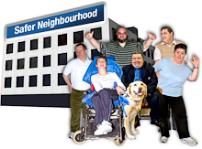Good place to live – the friendly city
We know Newcastle is a friendly city. But a good place to live can be more than this - it’s where your community helps you have control over your life. We believe having friends to rely on or being there for other people, accepting people from different cultures into your community and doing more to be “green “ can really make you feel better about the place you live.
What we have now
Newcastle has around 900 charities or similar groups and at least 2,500 voluntary or community groups. A lot of people are giving their time and energy to making Newcastle a better place to live already. About 1 in every 5 people does some voluntary work
What we want to see happen
- Look at the ways we give money to, or buy services from voluntary and community organisations to see if we can make more of the good things that communities have- both people themselves and groups

- Change our ways of working and give staff different skills and learning to help communities to think of ways to solve problems and take ideas forward themselves.

- Make sure the first thing all our staff, when they think about how they can do a better job, is working with others. This might be linking colleagues together using each other’s skills to solve problems, share good practice or simply trusting each other more

- We want to make the most of good news stories - this means telling people in the city and outside more about when people in Newcastle set up, lead and do projects and how these help to make people lives better.
Part Two: How services must change
This part of the plan is about
- What services must do as whole
- What they have to do to give everyone an equal chance of having good health and wellbeing
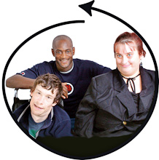What services and organisations must do as a whole
In tough times it’s easy for organisations think mainly about how they keep themselves going. But in Newcastle we know we have to keep thinking about the people we serve first and foremost – and we say all the way through this plan that we have to think about how we work together to do this such as:
- Learning from the good ways other places find out need arrange services and get people involved This might be other parts of the North East , the UK or the world
- Learning from each other in Newcastle
- Making thinking about what people can do – not what they can’t do is second nature to how we plan and make services happen
- Look at how health and social services buy services and how we can do this so it gives more joined up services to people
- Keeping people we work with up to date with what we are doing
- Make sure we use the information we gather about what people's needs (the Newcastle Future Needs Assessment) to see how service changes might affect people and what the best ways of changes services are
- Make sure we have clear ways of knowing when services are working well (measures) and people are getting healthier and happier
Promoting good health, stopping ill health
It’s never too early or late to
- Change your life to get healthier- finding out what’s good for you and the different ways you could make changes that suit the way you want to live. Then, having support from family friends neighbours or services to help you make changes
- Stop something that you do that could make you unhealthy
So for instance In Newcastle too many people smoke or drink too much and we want to support people to change.
The things we want to see happen
- We need to eat more healthily and do more exercise. But these need to become natural things that people do and everybody thinks are good ideas.
- We need to look at how services must change to promote health and stop people getting unhealthy
- Staff delivering services are well placed to spot people who have poor health now or who might become unhealthy.
- So we want make sure we have a clear way of identifying people and that staff know how to help people
- Staff can then, as part of their jobs, do things to help people early enough and give people themselves the chance to make changes to their lives. Some of this happens now like people having cancer screening or Health Checks. We want to make this happen for everyone.
- Look at all the ways we tell people about how to get healthy are joined up, say the same thing and can persuade people to change their lives
Jobs
How should services change to help people get and keep jobs?
- Look at all the services and support given to people who find it hard to get work and use this to change services to meet people’s needs better
- Improve how apprenticeships are organised and get more apprenticeships with local small business
- Make sure people who don’t have a job or who are at risk of losing their job can get help for any physical or mental health needs
Keeping people safe
Feeling and being safe is big part of anybody feeling being healthy and happy. People can be put at risk by what others do (abuse, hate crime) or don’t do (neglect) or thing that happen in the place where they live – like spread of disease or emergencies.
Everyone has a right to live their lives free from abuse and neglect. Everyone can play a part to make sure this happens. People who rely more on others help are more vulnerable. Public organisations must safeguard children and vulnerable adults.
What we have now
We have groups that look at how we safeguard children and adults (Safeguarding Boards). These have really good reputations because they do things properly like staff being trained, and when people think bad things have happened they are looked at properly. So we have something really good to build on now.

Things we want to see happen
We must ask our Safeguarding Boards to
- Make sure we do everything well that new laws coming in ( like Care and Support Bill ) ask us to do to keep people safe
- Learn from abuse and neglect that happens in other places like Winterbourne View or child abuse in Rochdale. We have to know how to stop this ever happening in Newcastle.
- Help staff and others to get better at spotting people who might be vulnerable especially if for instance they have substance misuse problems mental health problems or offending behaviour or they are living with someone who might be violent
- Immunisation and screening are very important to stop diseases spreading. So we have to make sure professional work better together so more people get immunised or screened when they should
- Work together to see how infections start in health and care services and how we stop these happening again

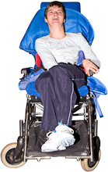People with Long term conditions
There are going to be more people with long term conditions in Newcastle as people get older.
What we have now
We have good quality health and social care services to meet people needs. We are doing work to help connect people known to services to local groups and communities so they can get involved and active where they want to be.

What we want to see happen
We need to keep our services high quality, make them better value for money and make sure they do all they can so people with long term conditions have a god quality of life
Make sure we look at how all services work together to support older people so people get help earlier to stop or slow down conditions getting worse and keep people independent
This will mean
- More connecting of people to groups and local communities
- Getting better at identifying people long term conditions
- Look at we can use technology more to keep people well and independent
Make sure we look at how all services work together to support people with mental problems so people get help earlier to stop or slow down conditions getting worse, keep people independent and give people a better quality of life. We will work with Gateshead on this
Make sure we look at how all services work together to support people who have complex needs like people with drug and alcohol abuse or homeless people so people get help earlier to stop or slow down conditions getting worse and keep people independent

