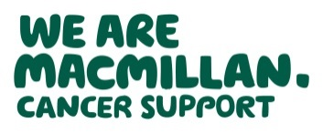
Improving safety netting for people with a learning disability

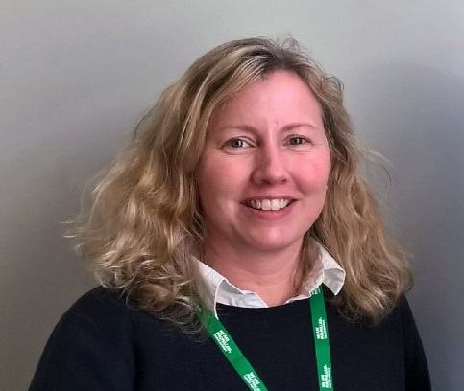 | I am doctor Katie Elliott.  I am a GP.  I work with the North East and Cumbria Learning Disability Network.  The network is working on improving safety netting.
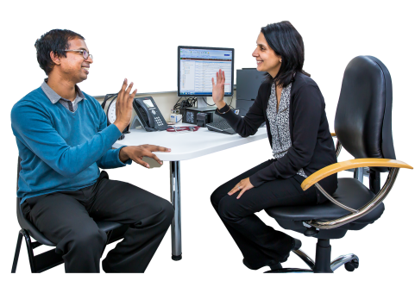 | What is safety netting?  When you go to the GP, they should work with you to decide what to do next.  This is a safety netting plan.
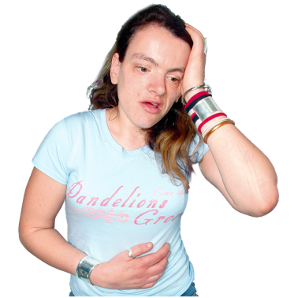  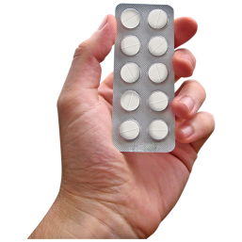 | Sometimes the doctor want to see you again to check how you feel.  Sometimes the doctor will want to see you again to tell you results of a test.  Sometimes the doctor recommends medicine or a test.  Sometimes the doctor will ask you to come back if there are changes in how you feel
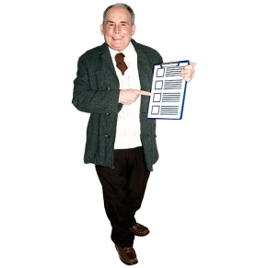 | We are working to find out what safety netting is best for people with learning disabilities.  We would like help to look at a safety netting tool for doctors to use.
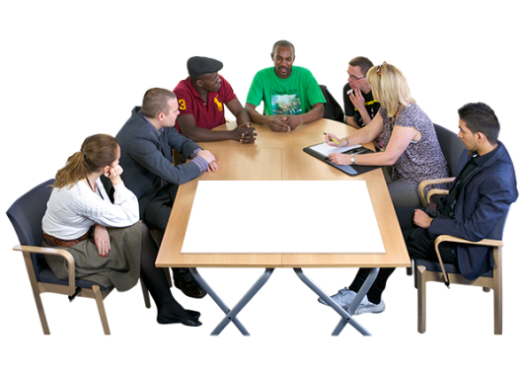 | This is an invitation to be part of a meeting about safety netting  At the meeting we will talk about safety netting and the safety netting tool.
 | Travel and volunteer expenses will be paid.
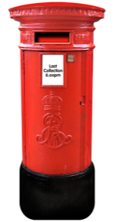 | If you would like come to a meeting let Katie know.  Katieelliott@nhs.net  Katie Elliott  Learning Disability Network  Waterfront 4  Goldcrest Way  Newburn Riverside  Newcastle Upon Tyne  NE15 8NY

