Top 10 tips to make yourself more accessible as a high street business
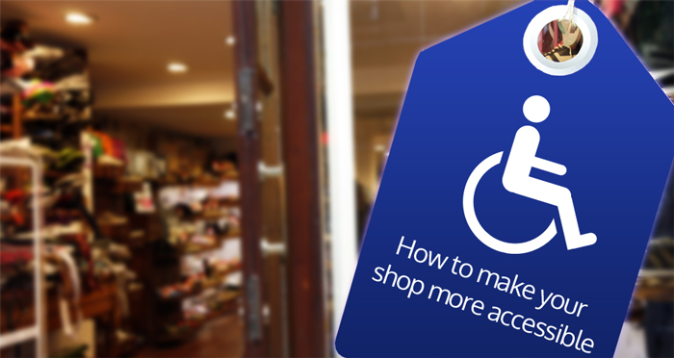

In light of the latest coverage on the BBC and national news about the accessibility of UK high street retailers, DisabledGo wanted to publish a top 10 list of things any business can do to drastically improve their access.

Our recent audit at DisabledGo found that a fifth of shops had no wheelchair access and three quarters of restaurants did not cater for those with visual impairments at all.
Some of our tips do require investment but some cost absolutely nothing, all these tips will greatly improve the experience of a disabled person trying to access your shop or facilities.
So without any further ado, here are DisabledGo’s top 10 tips to make yourself more accessible as a high street business:
- Have an access guide, similar to the ones on disabledgo.com, to give people confidence to use your business;
- Publish it clearly on your website;
- Invest in an accessible website (ReciteMe offer great accessibility tools);
- Invest in disability equality training;
- Put a hearing loop at the the till and customer service areas (they can be portable and fixed);
- Publish information/menus in large Arial font (minimum 16pt) on good contrasting colours;
- Keep aisles clear;
- Accessible doorways: consider electric doors if you are a large business; lighten the weight of doors for small stores; paint doors a different colour from the surround;
- Put card pin machines on an extendable wire (Latest story about pin machine discrimination on the BBC);
- Put a bell by steps if you can’t invest in a ramp.
And just in case you need some back up information…
Top 5 reasons why you should make yourself more accessible:
- £212bn annual spend of disabled people; (Family Resources Survey 2012/13)
- 6 million carers in the UK, most of whom are women, women make most family purchases;
- Disabled people influence the spending of others
- 4.3 million mobility aid users in the UK (Office of Fair Trading 2011)
- 3.3 million families with children under give who use pushchairs and prams (Office for Disability Issues, Growing your customer base 2012)

