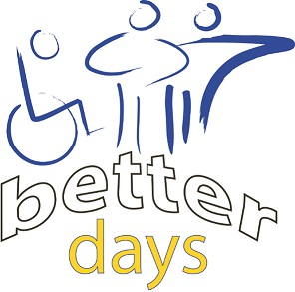
Friday 15th February 2019
10.30am – 1.45pm
Activity Day at Key House
If you are an adult with a learning disability
Come along and try a variety of indoor activities/sports
Armchair Yoga Indoor Target Golf Bingo
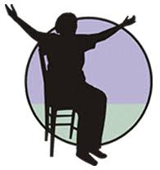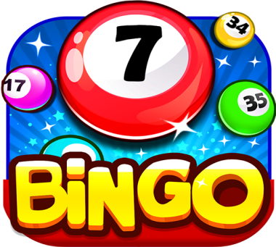
Free Refreshments
Skills for People, Key House
Tankerville Place, Jesmond
Newcastle upon Tyne, NE2 3AT
betterdays1999@hotmail.com or 0191 2815541

